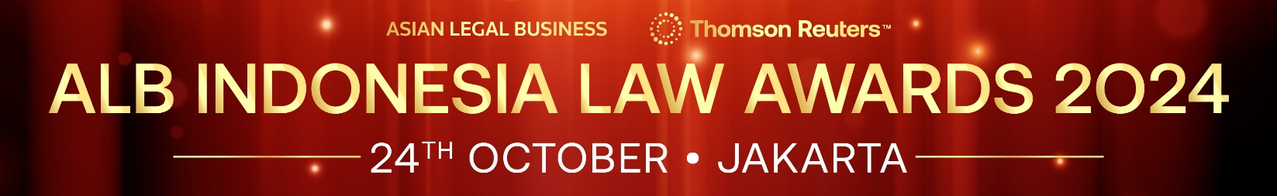

SUBMISSION FORM – IN-HOUSE CATEGORIES

Read the Research Methodology Summary before filling out the submission form.

Deadline for submissions – 2 August 2024 (Friday)
Send the completed forms to albawards@thomsonreuters.com

This form is for one category only. To submit another category, please complete a new form.
Save this form using the format: ALBILA2024-Category-Organisation
Example: ALBILA2024-Financial Services In-House Team of the Year-ABC Law Firm

Please send the submission form in Word format and do not convert it to PDF.

CHOOSE A CATEGORY HERE
Company (represented by the IH team)
A. BASIC INFORMATION
Industry
Country of residence (Confirm that the candidate is based in Indonesia.)
Team size (Specify the number of lawyers and non-lawyers based in Indonesia.)
Head of Legal Team
B. KEY WORK HIGHLIGHTS
KEY WORK NO. 1: (Indicate heading here)
Completion date (if applicable):
Description (max. of 500 words)

KEY WORK NO. 2: (Indicate heading here)
Completion date (if applicable):
Description (max. of 500 words)

KEY WORK NO. 3: (Indicate heading here)
Completion date (if applicable):
Description (max. of 500 words)

--------------------------------- Please add two more entries for Indonesia In-House Team of the Year. ----------------------

KEY WORK NO. 4: (Indicate heading here)
Completion date (if applicable):
Description (max. of 500 words)

KEY WORK NO. 5: (Indicate heading here)
Completion date (if applicable):
Description (max. of 500 words)

C. OTHER ACHIEVEMENTS (max. of 500 words)

