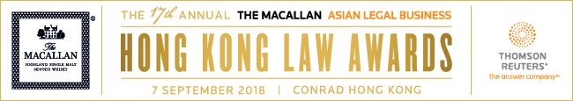

SUBMISSION FORM – FIRM CATEGORIES (III)

Read the Research Methodology Summary before filling out the submission form.

Deadline for submissions – 12 July 2018 (Thursday)
Submit the completed forms to mary.aquino@thomsonreuters.com.

For Deal Firm of the Year, please use Submission Form - Firm Categories (II).

For all the other firm categories, please use Submission Form - Firm Categories (I).

This form is for one category only. To submit for another category, please complete a new form.
Save this form using the format: Category_Organisation.

The Macallan Highland Single Malt Scotch Whisky Award Hong Kong Law Firm of the Year
Law firm
A. BASIC INFORMATION
Residence (Please indicate “Hong Kong” to confirm that the candidate is based therein.)
Firm size
Joiner/s in 2017 & 2018 (provide names and positions)
Departure/s in 2017 & 2018 (provide names and positions)

B. KEY WORK HIGHLIGHTS
KEY WORK NO. 1: (Indicate heading here)
Completion date:
Description (max. of 500 words)

KEY WORK NO. 2: (Indicate heading here)
Completion date:
Description (max. of 500 words)

KEY WORK NO. 3: (Indicate heading here)
Completion date:
Description (max. of 500 words)

KEY WORK NO. 4: (Indicate heading here)
Completion date:
Description (max. of 500 words)

KEY WORK NO. 5: (Indicate heading here)
Completion date:
Description (max. of 500 words)

KEY WORK NO. 6: (Indicate heading here)
Completion date:
Description (max. of 500 words)

KEY WORK NO. 7: (Indicate heading here)
Completion date:
Description (max. of 500 words)

KEY WORK NO. 8: (Indicate heading here)
Completion date:
Description (max. of 500 words)

KEY WORK NO. 9: (Indicate heading here)
Completion date:
Description (max. of 500 words)

KEY WORK NO. 10: (Indicate heading here)
Completion date:
Description (max. of 500 words)

C. INITIATIVES, PROJECTS & SOCIAL CONTRIBUTION
I. ORGANISATION: What were your firm's initiatives to engage, empower and develop its people? (max. of 300 words)

II. PROFESSION: What would your firm consider to be its most significant contribution to the legal community? (max. of 300 words)

III. COMMUNITY: Does your firm adopt a Corporate Social Responsibility (CSR) program? What are its distinct features and core activities? Cite the firm's most effective and inspiring CSR activity from 1 January 2017 to 30 April 2018. (max. of 300 words)

D. OTHER ACHIEVEMENTS (max. of 300 words)

